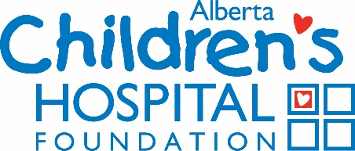

UNDESIGNATED BEQUEST
Residual Bequest: Designates all or a portion of whatever remains after all debts, taxes, expenses and all other bequests have been paid.

“I give _________[a portion of, example: “25% of”; all of, example: “100% of”] the rest and residue of my estate to the Alberta Children’s Hospital Foundation, in the City of Calgary, Alberta, to be used for such purposes as the Board of Directors of the Alberta Children’s Hospital Foundation may from time to time determine. I declare that the official charitable donation receipt shall be a sufficient discharge of my Executor.”

Specific Bequest: Directs that the Alberta Children's Hospital Foundation receives a specific amount or a certain kind of property, for example, a gift of shares.

“I give _______ to the Alberta Children’s Hospital Foundation in the City of Calgary, Alberta, to be used for such purposes as the Board of Directors of the Alberta Children’s Hospital Foundation may from time to time determine. I declare that the official charitable donation receipt shall be a sufficient discharge of my Executor.”

DESIGNATED BEQUEST
Gifts may be directed to a particular area of the hospital. These gifts may also be residual or specific. “I give ________ to the Alberta Children’s Hospital Foundation in the City of Calgary, Alberta, to be used for ___________ child health and wellness research at the University of Calgary and the Alberta Children’s Hospital. I declare that the official charitable donation receipt shall be a sufficient discharge of my Executor.”

Power to Vary Clause: We recommend that you include language that permits the Alberta Children’s Hospital Foundation to use the gift for a different purpose if circumstances change that make it impossible or impracticable to carry out the original purposes.

“In the event that, in the opinion of the Board of Directors of the Alberta Children’s Hospital Foundation, it should become impossible, inadvisable, or impractical to apply this gift for said purpose, the gift may be used for other purposes consonant with the spirit and intention of this gift.”

We strongly encourage you to talk to your family about your plans and seek professional legal, estate planning and/or financial advice when making decisions about your gift to the Alberta Children's Hospital Foundation.

For more information, please contact Sheelagh Mercier at 403-955-8837, smercier@achf.com or Heather Stevens at 403-955-8847, hstevens@achf.com

