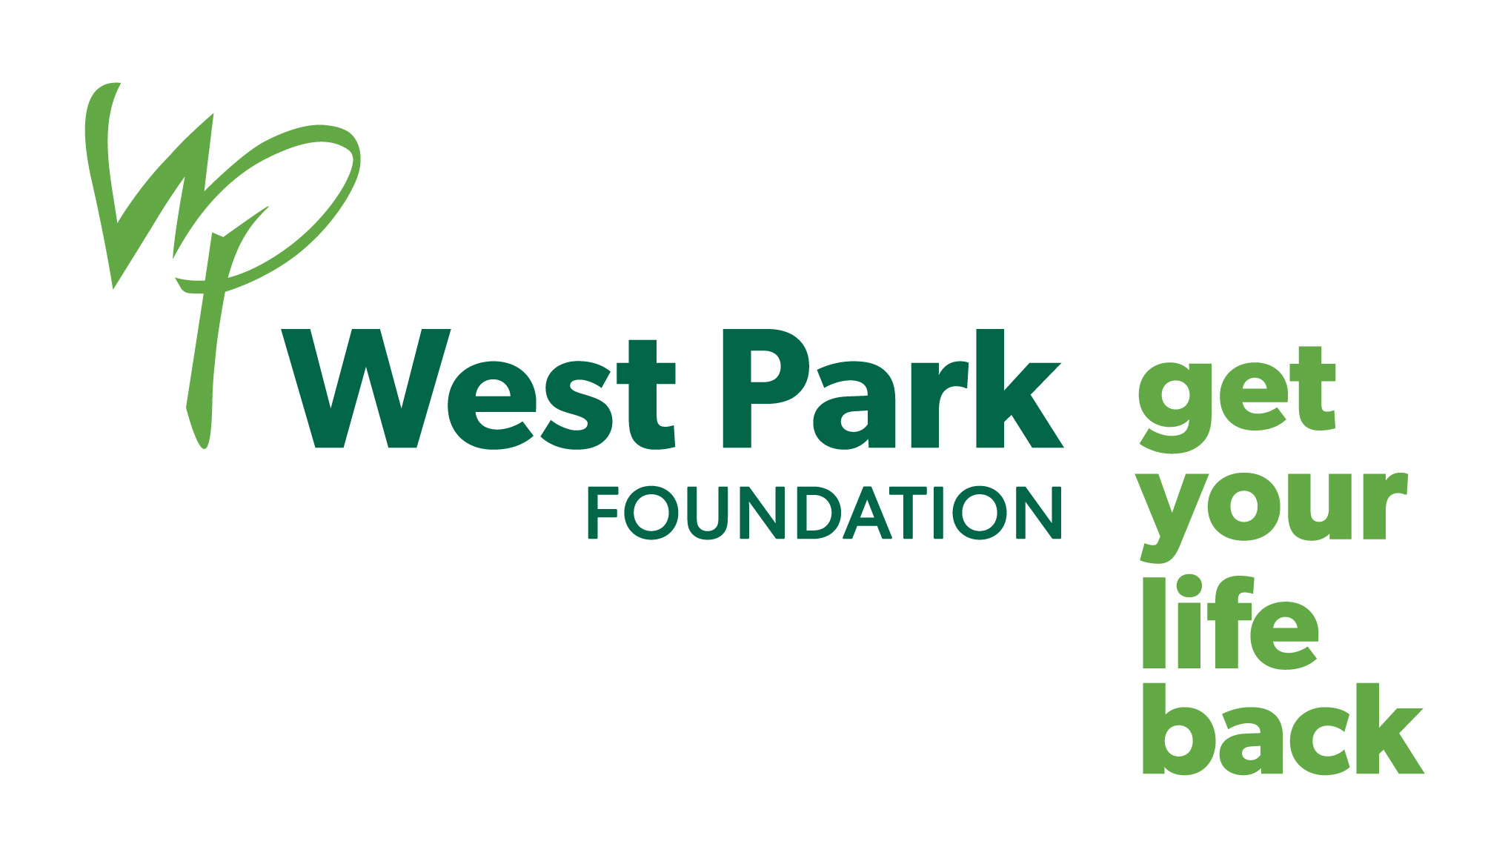

Sample Language for including a gift in your will to
West Park Healthcare Centre Foundation

Residual Bequest

I give West Park Healthcare Centre Foundation of 82 Buttonwood Avenue, Toronto, Ontario M6M 2J5, Charitable Business # 11929-5350-RR0001 _____ % of the rest, residue and remainder of my estate, to be used for the highest priority needs of said charity.

Specific Bequest

I give West Park Healthcare Centre Foundation of 82 Buttonwood Avenue, Toronto, Ontario M6M 2J5, Charitable # 11929-5350-RR0001, the sum of $_______ to be used for the highest priority needs of said charity.

Gift of Stock

I give West Park Healthcare Centre Foundation of 82 Buttonwood Avenue, Toronto, Ontario M6M 2J5, Charitable # 11929-5350-RR0001 all of my shares in XYZ Company / Mutual Fund to be used for the highest priority needs of said charity.

