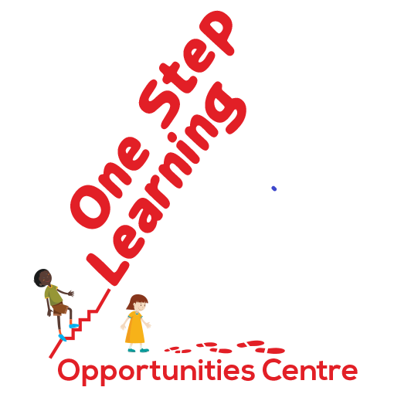
2022 – 2024 Early Childhood Learning Campaign

Making Early Childhood Learning Affordable
@ OSL Play-based daycare in Entumbil Ghana
We need You Please Give now
contact@onesteplearning.org
(+1) 780-717-4055

Early Childhood Learning Solicitation
Our goal is to raise $150,000 CAD over the next 3 years to operate a safe and healthy place for early children of Entumbil Ghana to learn and play; so, they would become lifelong learners of tomorrow.
Started by a founder donated building and outdoor space in October 2021 with 11 children, over 80 children, aged 1 to 4, now benefit from access to teachers, materials, a garden, and playground.
The parents now pay for around 25% of the cost of operation and we seek charitable donations, recognized with a tax saving receipt, to provide the remaining $30,000 needed annually for operating expenses. We are also seeking funding for a playground structure. Please spread your legacy here.
OSL is a registered Canadian Charity. Donations can be made through these platforms: CanadaHelps.org, CAGP-cpdp.org, ImagineCanada.ca, CharitableImpact.com, WillPower.ca, DonorPort.com, Benevitycauses.com and www.onesteplearning.org
Contact John@onesteplearning.org or (+1) 780-717-4055. Learn more… www.onesteplearning.org

Canada Revenue Agency (CRA) - Charity Business Registration #: 771608478 RR0001
Alberta Incorporation Corporate Access # 5122160921
Alberta Government Charitable Organization License Registration # 354251
Ghana Department of Social Welfare Registration # D.S.W. CR/AEEM/079/21, Category A
Ajumako-Enyan-Essiam District Assembly CBO-NPO Registration #s 665 and 666
OSL Platform Message
Making  Early  Childhood Learning  Affordable  One Step Learning (OSL) is a Canadian charity providing early childhood learning opportunities for impoverished children 1- to 4-year-olds in Entumbil, Ghana.  Support education for impoverished children with your meaningful strategic gift giving and tax credit.  www.onesteplearning.org Ph: +1 780-717-4055 | Our Message  One Step Learning believes in the integration of:  - Philanthropy  - Early Childhood Education (ECE); and  - Impact Agents for social good  The founders of OSL actioned an affordable daycare by donating the building and outdoor spaces of the Centre. Over $281,000 has been contributed. The daycare opened October 2021.  Parents pay $11,600 annually and projected expenses are $42,200. OSL needs new sources of funding for the $30,600 or $2,550 monthly shortfall for daily operational needs. Long-term items & a playground needed will cost $97,000.  Make an impact with your strategic meaningful gift giving so that children become lifelong learners of tomorrow in your name and legacy.
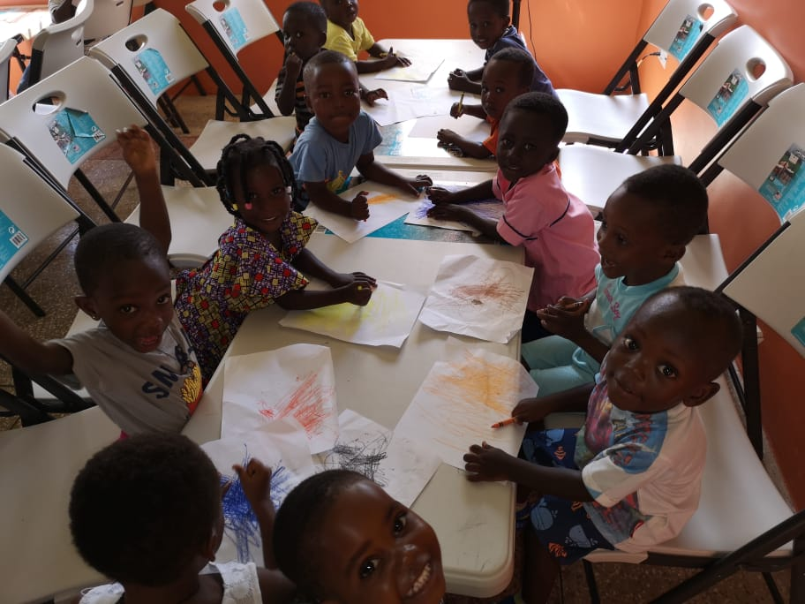  Over 80 children served will benefit from indoor educational materials | 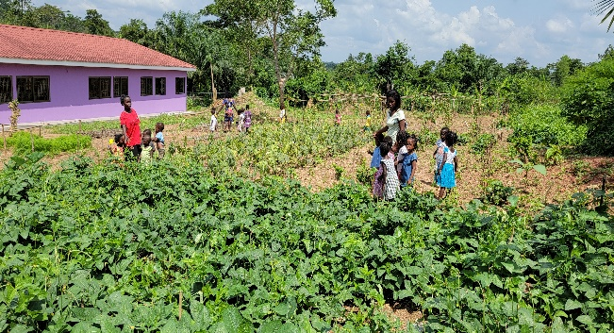  The innovative learning garden uses the world around us to solidify learning
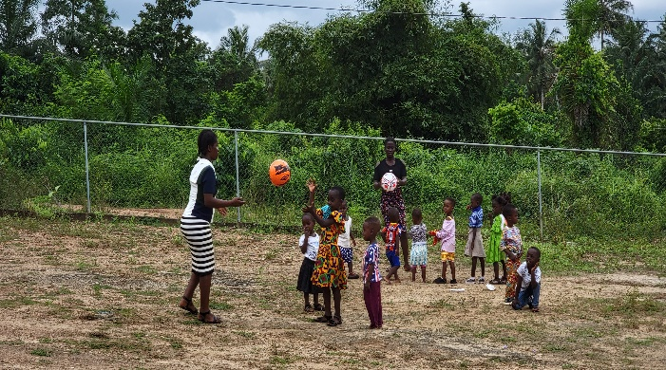  OSL children pray for outdoor playground equipment and transportation | 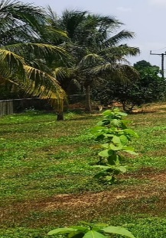  Another innovation, plant Teak trees on-site to symbolize longevity bond with OSL and named supporters. Claim one ✌✅ 👍. Find OSL on these platforms and donate:  - Canadian Association of  Gift Planners (cagp-cpdp.org)  - WillPower.ca  - CanadaHelps.org  - CharitableImpact.com  - ImagineCanada.ca  We’re avenue for social good!  Learn more - (link to www.onesteplearning.org )

